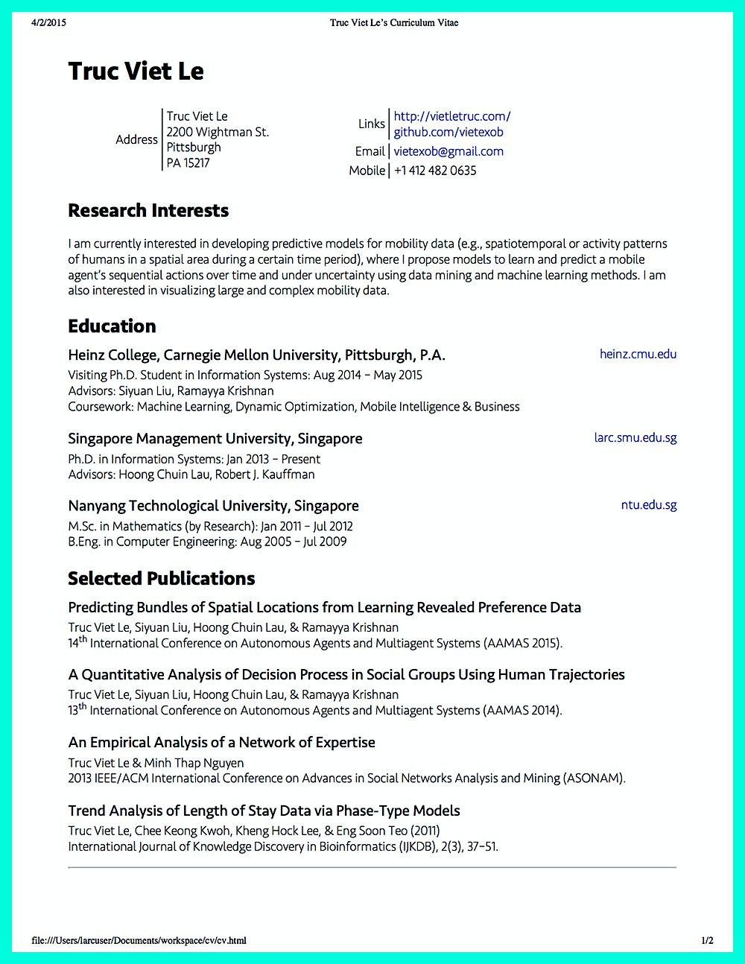
4/2/2015
Truc Viet Le's Curriculum Vitae
Truc Viet Le
Address
Truc Viet Le 2200 Wightman St. Pittsburgh PA 15217
Links
http://vietletruc.com/ github.com/vietexob
Email vietexob@gmail.com Mobile +1 412 482 0635
Research Interests
I am currently interested in developing predictive models for mobility data (e.g., spatiotemporal or activity patterns of humans in a spatial area during a certain time period), where I propose models to learn and predict a mobile agent's sequential actions over time and under uncertainty using data mining and machine learning methods. I am also interested in visualizing large and complex mobility data.
Education
Heinz College, Carnegie Mellon University, Pittsburgh, P.A.
Visiting Ph.D. Student in Information Systems: Aug 2014 - May 2015
Advisors: Siyuan Liu, Ramayya Krishnan
Coursework: Machine Learning, Dynamic Optimization, Mobile Intelligence & Business
Singapore Management University, Singapore
heinz.cmu.edu
larc.smu.edu.sg
Ph.D. in Information Systems: Jan 2013 - Present Advisors: Hoong Chuin Lau, Robert J. Kauffman
Nanyang Technological University, Singapore M.Sc. in Mathematics (by Research): Jan 2011 - Jul 2012 B.Eng. in Computer Engineering: Aug 2005 - Jul 2009
Selected Publications
Predicting Bundles of Spatial Locations from Learning Revealed Preference Data
Truc Viet Le, Siyuan Liu, Hoong Chuin Lau, & Ramayya Krishnan
14th International Conference on Autonomous Agents and Multiagent Systems (AAMAS 2015).
A Quantitative Analysis of Decision Process in Social Groups Using Human Trajectories
Truc Viet Le, Siyuan Liu, Hoong Chuin Lau, & Ramayya Krishnan
13th International Conference on Autonomous Agents and Multiagent Systems (AAMAS 2014).
An Empirical Analysis of a Network of Expertise
Truc Viet Le & Minh Thap Nguyen
2013 IEEE/ACM International Conference on Advances in Social Networks Analysis and Mining (ASONAM).
Trend Analysis of Length of Stay Data via Phase-Type Models
Truc Viet Le, Chee Keong Kwoh, Kheng Hock Lee, & Eng Soon Teo (2011)
International Journal of Knowledge Discovery in Bioinformatics (IJKDB), 2(3), 37-51.
file:///Users/larcuser/Documents/workspace/cv/cv.html
ntu.edu.sg
1/2

